PRACTICAL 7 : Obstacle Detector

Aim : To detect obstacles using an ultrasonic sensor and indicate the presence of objects.

Overview :
This project utilizes an ultrasonic sensor to detect obstacles and trigger an alert using LEDs or a buzzer. It demonstrates the application of distance measurement in real-time obstacle avoidance, a key concept in robotics and automation.

Materials Required :
- Arduino Uno R3
- 1 x 1 kΩ Resistor
- 1 x 250 kΩ Potentiometer
- 1 x 220 kΩ Resistor
- LCD 16x2
- Ultrasonic Distance Sensor (4-pin)
- Piezo
- Jumper Wires
- Arduino IDE (Installed on your Computer)

Circuit Connection and Steps :
- Ultrasonic Sensor (HC-SR04) : Connect VCC → 5V, GND → GND, Trig → D5 and Echo → D6.
- Buzzer Connection: Connect Positive (+) → D7 and Negative (-) → GND.
- Connect the 16x2 LCD Display to Arduino :
  - RS → A5, E → A4
  - D4-D7 → D9, D8, D10, D11
  - VSS, RW, K → GND, VDD, A → 5V

Circuit Diagram :
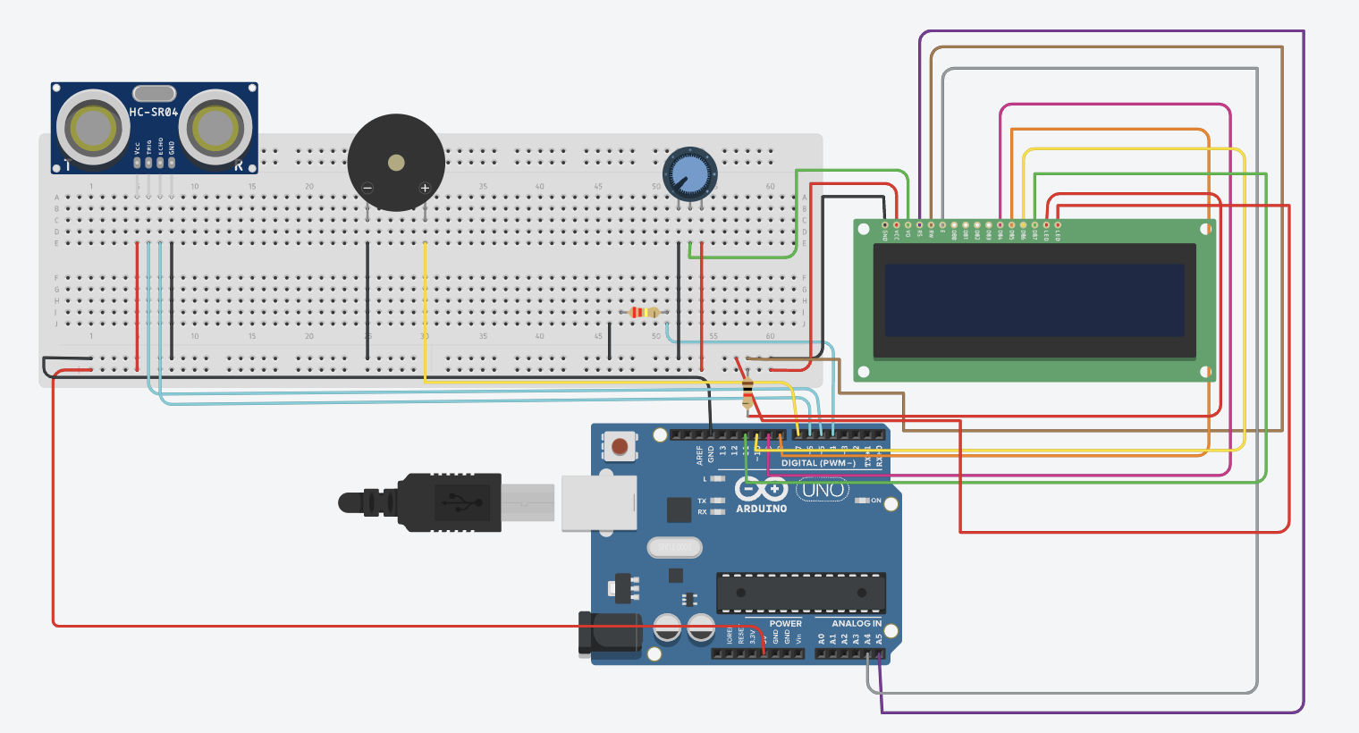
Schematic Diagram :
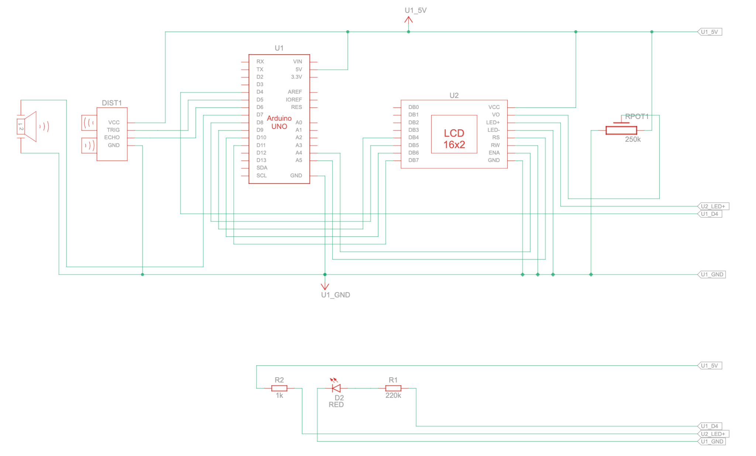

Code :
#include <LiquidCrystal.h>
// Pin Assignments
int redPin = 13, yellowPin = 12, greenPin = 11, buzzerPin = 7;
int echoPin = 6, triggerPin = 5;
int lcdRs = A5, lcdEn = A4, lcdD4 = 9, lcdD5 = 8, lcdD6 = 10, lcdD7 = 11;
LiquidCrystal lcd(lcdRs, lcdEn, lcdD4, lcdD5, lcdD6, lcdD7);
unsigned long lastTime = millis(), timeDelay = 100;
void setup() {
lcd.begin(16, 2);
Serial.begin(115200);
int pins[] = {redPin, yellowPin, greenPin, buzzerPin, triggerPin};
for (int i = 0; i < 5; i++) pinMode(pins[i], OUTPUT);
pinMode(echoPin, INPUT);
}
void loop() {
if (millis() - lastTime > timeDelay) {
lastTime = millis();
measureDistance();
}
}
void measureDistance() {
digitalWrite(triggerPin, LOW); delayMicroseconds(2);
digitalWrite(triggerPin, HIGH); delayMicroseconds(10);
digitalWrite(triggerPin, LOW);
double distance = pulseIn(echoPin, HIGH) / 58.0; // Convert to cm
lcd.setCursor(0, 0); lcd.print("Distance: " + String(distance, 1) + "cm ");
if (distance > 336 || distance <= 0) {
updateOutput(0, 0, 0, 0, "Out of Range");
return;
}
if (distance <= 20) updateOutput(450, 0, 0, 1, "Object: NEAR ");
else if (distance <= 100) updateOutput(400, 300, 200, 0, "Object: MID ");
else updateOutput(350, 500, 500, 0, "Object: FAR ");
}
void updateOutput(int freq, int beepOn, int beepOff, bool continuous, String message) {
lcd.setCursor(0, 1); lcd.print(message + " ");
digitalWrite(redPin, freq == 450);
digitalWrite(yellowPin, freq == 400);
digitalWrite(greenPin, freq == 350);
if (freq == 0) noTone(buzzerPin);
else if (continuous) tone(buzzerPin, freq);
else { tone(buzzerPin, freq); delay(beepOn); noTone(buzzerPin); delay(beepOff); }
}

Results :
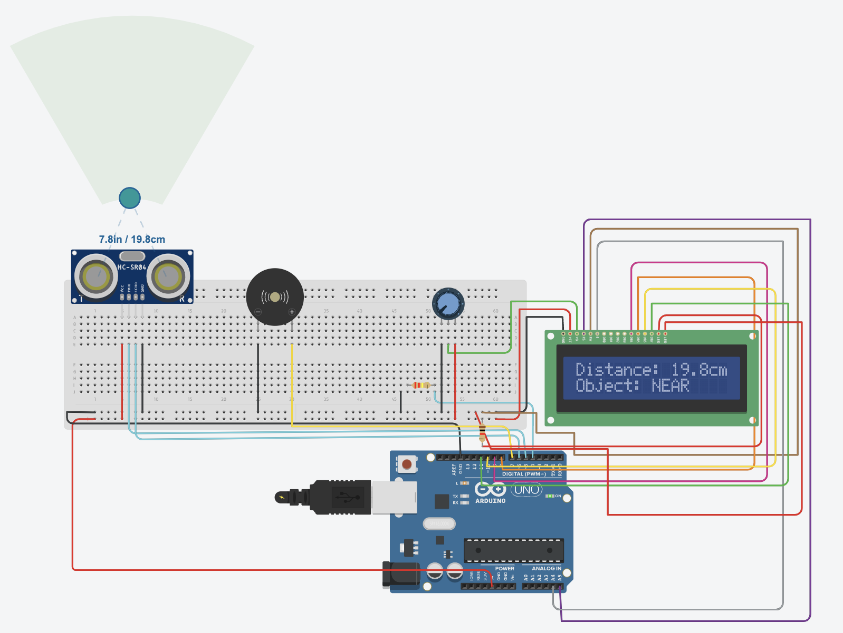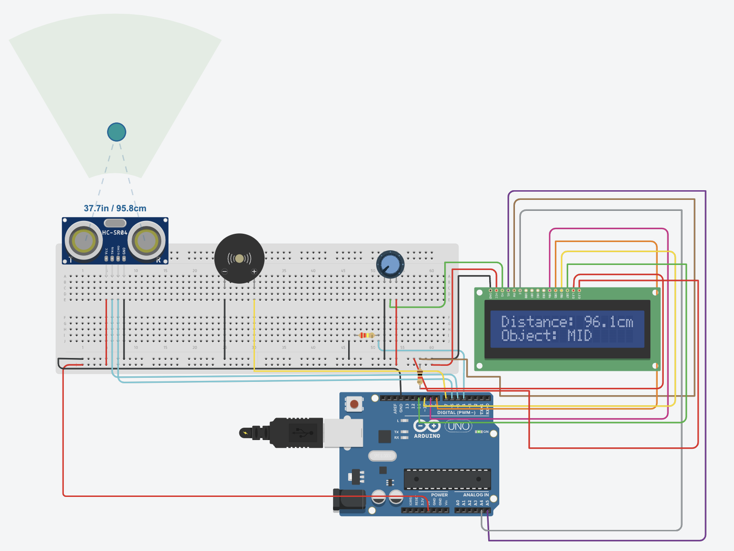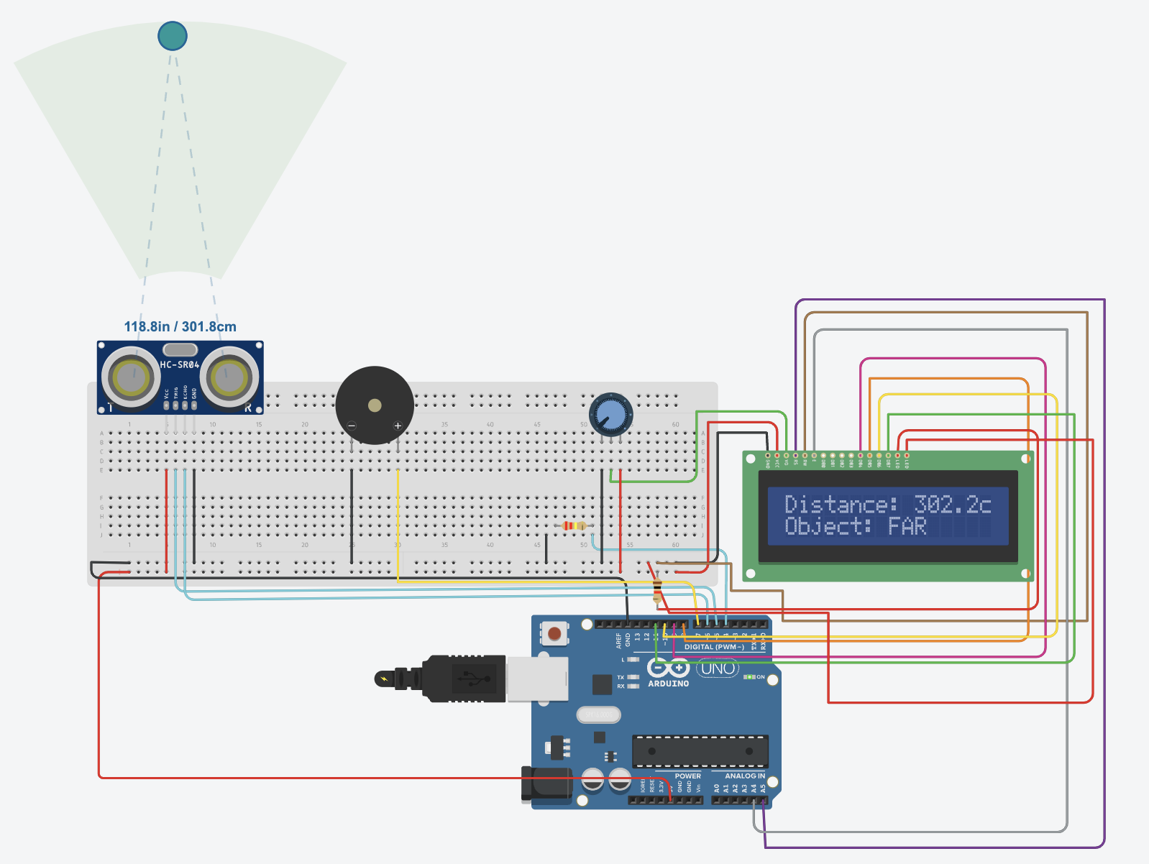
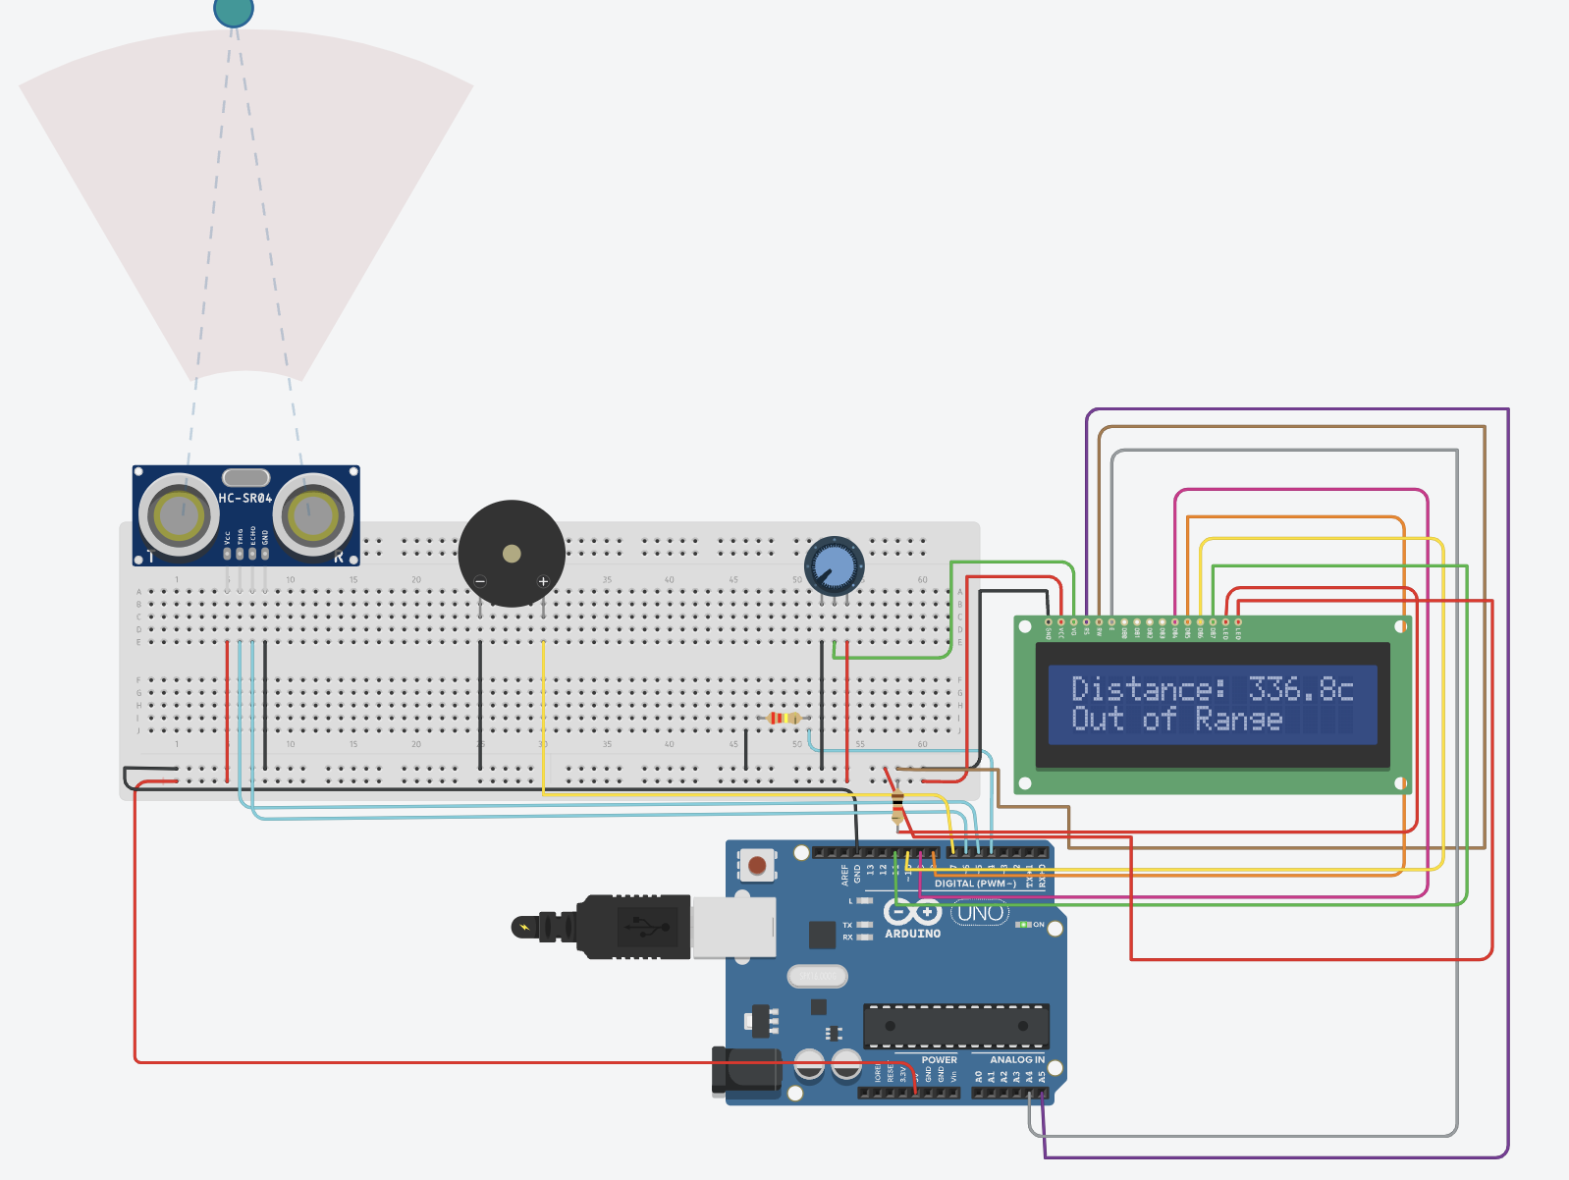

Conclusion :
The Obstacle Detector project successfully detects nearby objects using an ultrasonic sensor and triggers an alert system. It highlights the importance of real-time sensing in automation and robotics. This experiment serves as a foundation for applications like autonomous vehicles, security systems and smart navigation.

